**Face Detection:**

1. **bd607c32ecb24656a4f51e7e1407f9e8**
2. d835ede59ee24286b7c239dc0c4cda08

create api reference and go to face list and click on create face list(all the faces will be grouped under this facelist),select west

facelistid-faces_great_personalities

ocp-key is the one which is created when we subscribed for api.

under request body, in the code, in name: change to the same face list name(faces_great_personalities).

Click on send, if resposnse is 200 OK….that means its perfect.

To make sure that the face list is created, goto Facelist andselect list face list., select west, paste the same ocp id and send.

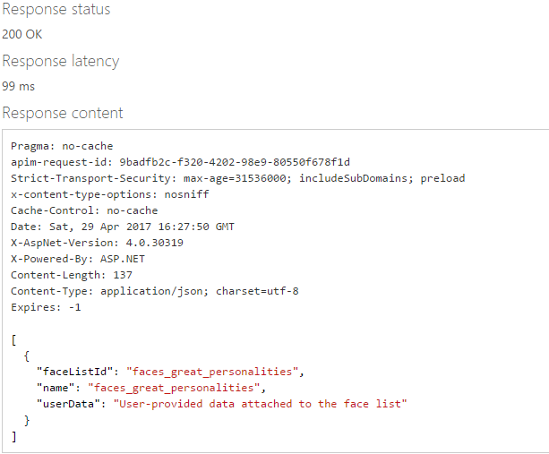

Open the entire project folder and in ms-services->faceAPI.js -> MS_COGNITIVE_SUBSCRIPTION_KEY paste the same key which u have generated.